**Practical No: - 5**

**Aim: Create a fuzzy logic system for Washing Machine using MATLAB.**

1. **INTRODUCTION TO WASHING MACHIN’S WORKING :**

A washing machine basically works in three cycles. These are washing, rinsing and spinning. Different mechanical parts work together to carry out each cycle. In the operation water enters the washing machine through little pipes. The motor starts to turn the washing machine's inner tub. The water drains through these holes in the inner tub. The water gets there due to the spinning of the tub and centrifugal force. These components have to be present in any type of washing machine: inner wash tub (involves the adding of water and detergent mixture to the clothes), agitator (which enhances the action of detergents enzymes on clothes), motor (which accelerates the process of washing), outer wash tub (where discharge the detergent particles trapped in the washed fabric), drain tube (which is called the spin cycle, is to remove out as much water as possible from the wet clothes) and power parts which modulates the speed to smoothen the start-up effect.

Before starting to use the washing machine, one needs to consider a few elements such as the load of the clothes, temperature of the water, rinse cycles and their durations. The machine fills the tub with water after the clothes are filled in the tub. The machine stirs the clothes around the agitator and after some time, the washer drains the water and spins the clothes to remove most of the water. It then refills and agitates the clothes some more so as to rinse out the soap and then drains and spins again. In each of the four corners of the machine, there is a mechanism that works a like a disc brake. The part attached to the washer frame is a spring which squeezes two pads against the metal plate that is attached to the black frame. One can see where the pads have polished the plate from the movement during vibration.

**The Parts of an Air Conditioner**

**1) Water inlet control valve**: Near the water inlet point of the washing there is water inlet control valve. When you load the clothes in washing machine, this valve gets opened automatically and it closes automatically depending on the total quantity of the water required. The water control valve is actually the solenoid valve.

**2) Water pump**: The water pump circulates water through the washing machine. It works in two directions, re-circulating the water during wash cycle and draining the water during the spin cycle.

**3) Tub**: There are two types of tubs in the washing washing machine: inner and outer. The clothes are loaded in the inner tub, where the clothes are washed, rinsed and dried. The inner tub has small holes for draining the water. The external tub covers theinner tub and supports it during various cycles of clothes washing.

**4) Agitator or rotating disc**: The agitator is located inside the tub of the washing machine. It is the important part of the washing machine that actually performs the cleaning operation of the clothes. During the wash cycle the agitator rotates continuously and produces strong rotating currents within the water due to which the clothes also rotate inside the tub.

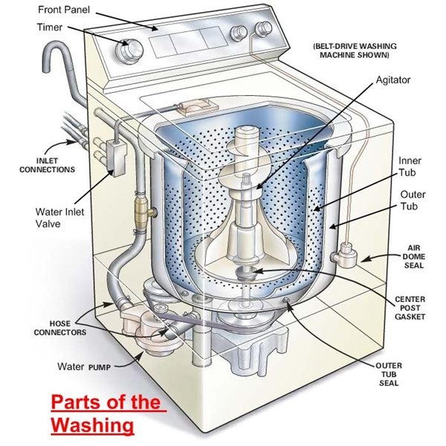

In some washing machines, instead of the long agitator, there is a disc that contains blades on its upper side. The rotation of the disc and the blades produce strong currents within the water and the rubbing of clothes that helps in removing the dirt from clothes.

**5) Motor of the washing machine**: The motor is coupled to the agitator or the disc and produces it rotator motion. These are multispeed motors, whose speed can be changed as per the requirement. In the fully automatic washing machine the speed of the motor i.e. the agitator changes automatically as per the load on the washing machine.

**6) Timer**: The timer helps setting the wash time for the clothes manually. In the automatic mode the time is set automatically depending upon the number of clothes inside the washing machine.

**7) Printed circuit board (PCB)**: The PCB comprises of the various electronic components and circuits, which are programmed to perform in unique ways depending on the load conditions (the condition and the amount of clothes loaded in the washing machine). They are sort of artificial intelligence devices that sense the various external conditions and take the decisions accordingly. These are also called as fuzzy logic systems. Thus the PCB will calculate the total weight of the clothes, and find out the quantity of water and detergent required, and the total time required for washing the clothes. Then they will decide the time required for washing and rinsing.

**8) Drain pipe**: The drain pipe enables removing the dirty water from the washing that has been used for the washing purpose.

**STEPS TO IMPLEMENT FIS FOR WASHING MACHINE IN MATLAB**

1. **Select the no of inputs:** in washing machine system we have taken three inputs. The three inputs are as following :

Type of cloth

Type of dirtness

Water-level [17 60 litre]”

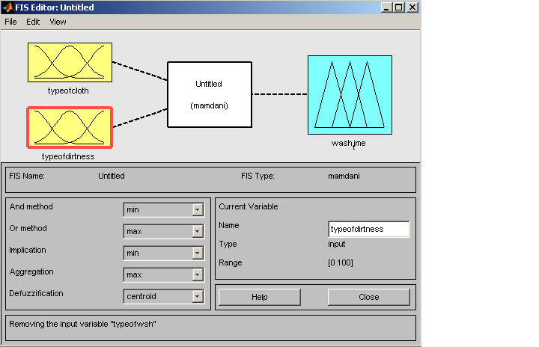

1. **Membership functions for all inputs and its linguistic variables:**

PROGRAM [10 47]:

|  |  |
| --- | --- |
| *linguistic variable* | *membership function* |
| Normal | Guassmf |
| Medium | Guassmf |
| Heavy | Guassmf |

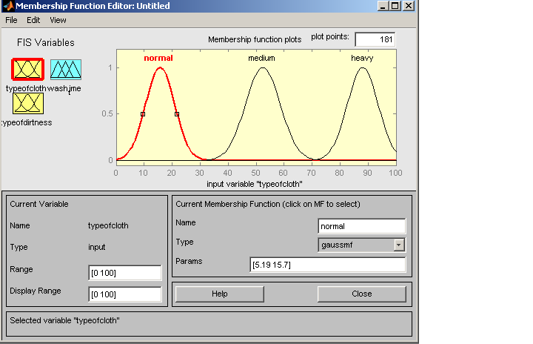

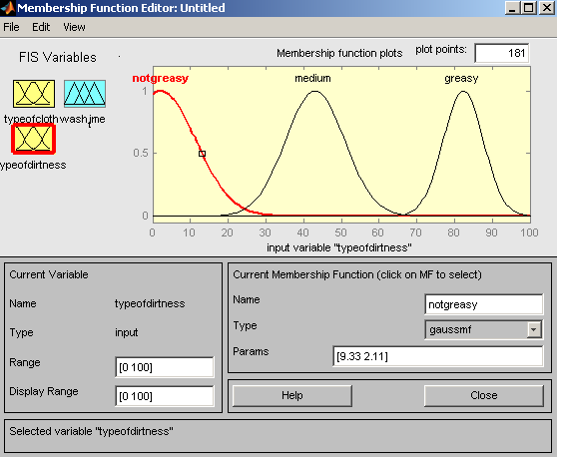

|  |  |
| --- | --- |
| *linguistic variable* | *membership function* |
| Not greasy | Gauss2mf |
| Medium | Gauss2mf |
| Greasy | Gauss2mf |

1. **Select the no of output :** in this system the no of outputs are two as following :

Washtime

1. **Membership functions for all outputs and its linguistic variables :**

TIME[8-60 sec]:

|  |  |
| --- | --- |
| *linguistic variable* | *membership function* |
| Less | Guassmf |
| Medium | Guassmf |
| More | Guassmf |

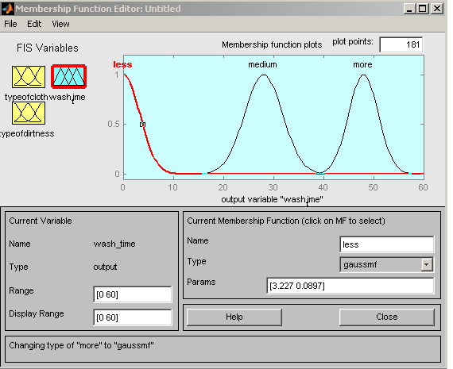

1. **Rules for Washing Machine Fuzzy inference system**

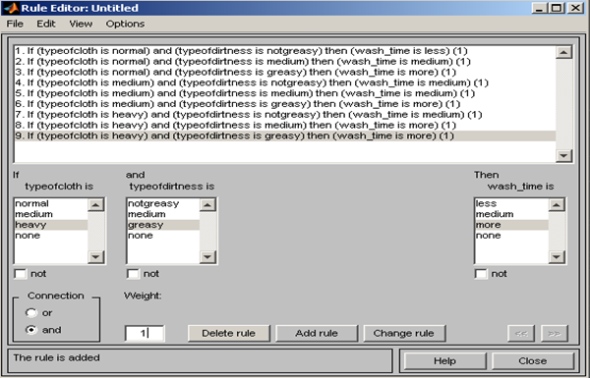

1. **Output of rules in rule viewer/ surface viewer :**

In this screen shot the inputs are water-level and Program and output shown is the time.

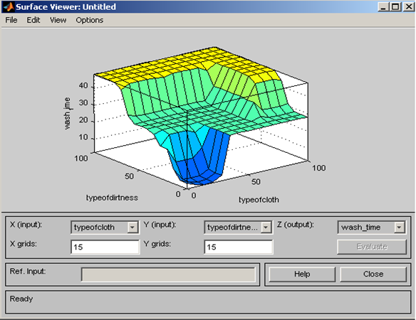

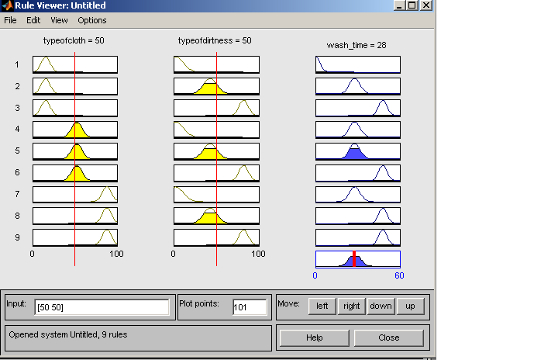

In above screen shot the inputs are type of cloth is 50, type of dirtness is 50 and wash then the output of wash time is 28. This output is based on seventh rule defined in the FIS.

**In this FIS system :**

**Implication method is : Min**

**Aggregation method is : Max**

**Defuzzification method is : Centroid**

Thus the whole FIS is design in the matlab.

**PROGRAM:**

functionvarargout = gui1(varargin)

gui_Singleton = 1;

gui_State = struct('gui_Name', mfilename, ...

'gui_Singleton', gui_Singleton, ...

'gui_OpeningFcn', @gui1_OpeningFcn, ...

'gui_OutputFcn', @gui1_OutputFcn, ...

'gui_LayoutFcn', [] , ...

'gui_Callback', []);

ifnargin&&ischar(varargin{1})

gui_State.gui_Callback = str2func(varargin{1});

end

ifnargout

[varargout{1:nargout}] = gui_mainfcn(gui_State, varargin{:});

else

gui_mainfcn(gui_State, varargin{:});

end

function gui1_OpeningFcn(hObject, eventdata, handles, varargin)

handles.output = hObject;

guidata(hObject, handles);

functionvarargout = gui1_OutputFcn(hObject, eventdata, handles)

varargout{1} = handles.output;

function slider1_Callback(hObject, eventdata, handles)

x = get(handles.slider1,'Value')

set(handles.text1,'String',num2str(x))

function slider1_CreateFcn(hObject, eventdata, handles)

usewhitebg = 1;

ifusewhitebg

set(hObject,'BackgroundColor',[.9 .9 .9]);

else

set(hObject,'BackgroundColor',get(0,'defaultUicontrolBackgroundColor'));

end

function slider2_Callback(hObject, eventdata, handles)

y = get(handles.slider2,'Value')

set(handles.text2,'String',num2str(y))

function slider2_CreateFcn(hObject, eventdata, handles)

usewhitebg = 1;

ifusewhitebg

set(hObject,'BackgroundColor',[.9 .9 .9]);

else

set(hObject,'BackgroundColor',get(0,'defaultUicontrolBackgroundColor'));

end

function pushbutton1_Callback(hObject, eventdata, handles)

p = get(handles.slider1,'Value');

q = get(handles.slider2,'Value');

a=newfis('wash_machine1');

a = addvar(a,'input','x',[0 100]);

a = addmf(a,'input',1,'A1','trimf',[0 0 50]);

a = addmf(a,'input',1,'A2','trimf',[0 50 100]);

a = addmf(a,'input',1,'A3','trimf',[50 100 100]);

a = addvar(a,'input','y',[0 100]);

a = addmf(a,'input',2,'B1','trimf',[0 0 50]);

a = addmf(a,'input',2,'B2','trimf',[0 50 100]);

a = addmf(a,'input',2,'B3','trimf',[50 100 100]);

a = addvar(a,'output','z',[0 60]);

a = addmf(a,'output',1,'C1','trimf',[0 8 12]);

a = addmf(a,'output',1,'C2','trimf',[8 12 20]);

a = addmf(a,'output',1,'C3','trimf',[12 20 30]);

a = addmf(a,'output',1,'C4','trimf',[30 40 50]);

a = addmf(a,'output',1,'C5','trimf',[50 60 70]);

rulelist=[ ...

1 1 1 1 1

2 2 3 1 1

3 3 5 1 1

1 2 3 1 1

1 3 3 1 1

2 1 2 1 1

2 3 4 1 1

3 1 2 1 1

3 2 4 1 1 ];

a=addrule(a,rulelist);

z = evalfis([p q], a)

set(handles.text3,'String',num2str(z))

set(handles.slider4,'Value',z)

function slider3_Callback(hObject, eventdata, handles)

function slider3_CreateFcn(hObject, eventdata, handles)

usewhitebg = 1;

ifusewhitebg

set(hObject,'BackgroundColor',[.9 .9 .9]);

else

set(hObject,'BackgroundColor',get(0,'defaultUicontrolBackgroundColor'));

end

function slider4_Callback(hObject, eventdata, handles)

function slider4_CreateFcn(hObject, eventdata, handles)

usewhitebg = 1;

ifusewhitebg

set(hObject,'BackgroundColor',[.9 .9 .9]);

else

set(hObject,'BackgroundColor',get(0,'defaultUicontrolBackgroundColor'));

end